# -

**---🙠**🕮**🙢---**

**This is to certify that**

**Mr./Ms:**

Student789491 ANH TRAN TUAN

Student789677 HIEN LE THANH

Student789690 KHOA PHAN VIET

Student789648 DU NGUYEN HOANG

**Has successfully Designed & Developed**

**---** Star Security Services ---

**Submitted by:**

Group 2

**Date of Issue:**

**26/04/2014**

**Authorized Signature:**

I. Problem Definition (Form No. 1):

|  |
| --- |
| Introduction:  *Star securities* has been one of the pioneers in the Private Security Industry. Set up in 2000, Star is an ISO 9001:2000 certified public limited company, the company has grown into a "Total Security Solutions Provider" offering manned guarding (MG), investigations (C&I), electronic security systems (ESS) and cash services (CS) to over 250 corporate customers across 24 states. Backed by a trained workforce of over 2800 men & supervisors and 100 banded managers. With the variety of services and massive staff, the company has proposed to open a website easily introduced to customers around the world quickly the old and new service. At the same time can easily manage information of employees, customers and orders of service from any place as long as there is have browser and internet. In addition, the company also wanted to use website to post information of company recruiters for who have the desire to work for the company can easily know.  ****A web-site incorporating all the information about the Star security services is required with following functionality****   * Main service: Manned guarding, Cash services, Recruitment and training, Electronic sercurity systems * Only employees can login * The employees just access to the website content as per their role * Add/update/delete the details of the employees, clients details, vacancies, services offered |

II. Customer Requirement Specification(CRS) (Form No. 2):

|  |
| --- |
| Client: ***Star security company***  Business / Project Objective: Website is capable of managing large records of communication service: details of customers, employees, service, vacancy... Records are stored in database which can automate the system. This website can easily solve the complexity and vastness of the system.We provided convenient way for customer to use our services, they can enquire regarding the connection or place an order for the connection by directly visiting to the website in anywhere which have internet and browser.Employee can easily search for the information of customers, besides they can easily search for the status of the order the had manager through the unique order id.Feedback from customer help company to work better and provide the best services. Beside, to increase the comfort level of the customers, customer can have a discount when start a bulk and corporate schemes, payments are suitable for any customer. Specially, system are updated in real time with queries and newest services.  * Input provide by the client   + Inputs to the System:     - Employee: EmployeeID, Fullname, Password, TitleID, Gender, Address, CityID, BirthDate, HireDate, Phone, EduQualID, Achievements, RoleID, Email     - Customer: CustomerID, CustomerName, CompanyName, TitleID, Address, CityID, Phone, Gender     - Vacancies: VacancyID, Quantity, ExprirationDate, Description, EduQualID, Salary, TitleID     - Service: ServiceID, FunctionID, ServiceName, Information, Price, PhotoPath     - Order: OrderID, CustomerID, EmployeeID, Sum     - OrderDetail: OrderDetailID, OrderID, ServiceID, Quantity, Total, StartDate, ExpirationDate     - City: CityID, City     - EduQual: EduQualID, EduQual     - Title: TitleID, Title     - About: Chairman, Directors     - Region: RegionID, RegionDescription, Address, Details, Person     - Contact: ContactID, Fullname, Email, Time, Comment, Status     - RegisVacancies: RegisID, VacancyID, Fullname, TitleID, Gender, Address, CityID, BirthDate, Phone, EduQualID, Achievements, Email, Pass   + Output from the System:     - List of Employee     - List of Customer     - List of Vacancies     - List of Order     - List of OrderDetail     - List of Title     - List of City     - List of Education Quality     - List of Service     - List of RegisVacancies     - List of Contact   + Process Involved in the System:     - Login     - Logout     - Change password     - Forget Password     - Registration Employee     - Update information of Employee     - Remove Employee     - Registration Customer     - Update information of Customer     - Remove Customer     - Add Vacancies     - Update information of Vancancies     - Remove Vacancies     - Add Service     - Update information of Service     - Remove Service     - Add Order     - Remove Order     - Add Order Detail     - Update information of Order Detail     - Remove Order Detail     - Add City     - Update information of City     - Remove City     - Add Education Quality     - Update information of Education Quality     - Remove Education Quality     - Add Title     - Update information of Title     - Remove Title     - Add RegisVacancies     - Update RegisVacancies     - Send Interview     - Send Contact     - Reply Contact     - Search Employee     - Search Customer     - Search Title     - Search City     - Search EduQual     - Search Service     - Edit Region     - Edit About * Expected Delivery Dates: 26-april-2014 * List of Deliverables:   + Document:     - User manual     - Installation guide     - Document project     - Source code * Hardware Requirements:   + Client:     - 1024 Megabytes of RAM or higher     - A minimum computer system that will help you access browers   + Server:     - A minimum computer system that will help you access all the tools in the courses is a Pentium 200 or a higher capability CPU     - 2048 Megabytes of RAM or higher     - HDD: 20GB or higher * Software Requirements:   + Client:     - Windows XP or later     - Browsers (IE, Chrome, Firefox, Opera, …)   + Server:     - Windows server 2003 or later     - IIS     - SQL server 2005 or later     - Integrated Development Environment (IDE) * Scope of the Work (in brief):   + Login, Logout   + Change password, Forget Password   + Registration/ Update/ Remove Employee   + Registration/ Update/ Remove Customer   + Registration/ Update/ Remove Service   + Add / Update/ Remove Vacancies   + Add /Remove Order   + Add / Update/ Remove OrderDetail   + Add / Update/ Remove City   + Add / Update/ Remove EduQual   + Add / Update/ Remove Title   + Send/ Reply Contact   + Add/Update RegisVacancies   + Send Interview   + Search Employee/ Customer/ City/ EduQual/ Service/ Title   + Edit Region/ About |

III. Architecture & Design of the Project (Form No. 3):

Since the application will be made of a Web-based distributed three-tier architecture to support multiple user transactions at the same time

**Web-Based Distributed 3-Tier Architecture of the Project**

**Web-Tier**

**Middle-Tier**

**Database-Tier**

**User interface**

**With HTML and**

**ASPX pages**

**C# (Code-behind) files, containing,**

**business logic**

**SQL Server 2005**

**IV. Flow Chart (Form No.4):**

**⏹ Login**

|  |  |
| --- | --- |
| C:\Users\ACER\Desktop\Luu_Do\Hinh\Login.jpg | Input: EmployeeID, Password |
| Validate:  + Username is not empty  + Password is not empty |
|  |  |

**⏹ Change Password**

|  |  |
| --- | --- |
| C:\Users\ACER\Desktop\Luu_Do\Hinh\Change password.jpg | Input: Old password; New password; Confirm new password |
| Validate:  +Password not empty  +Old password is true  + New password and confirm password have the same |
| C:\Users\DELL\Desktop\New folder (3)\changepasss.PNG |  |

**⏹ Forget Password**

|  |  |
| --- | --- |
| C:\Users\ACER\Desktop\Luu_Do\Hinh\Forget Password.jpg | Input: Answer |
| Validate: |
|  |  |

**⏹ Registration Employee**

|  |  |
| --- | --- |
| C:\Users\ACER\Desktop\Luu_Do\Hinh\Registration Employee.jpg | Input: EmployeeID, Fullname, TitleID, Gender, Address, CityID, RegionID, BirthDate, HireDate, Phone, EduQualID, Achievements, RoleID |
| Validate:  + All row not empty  + Birthdate must be selected or enter  Fomat : dd-MM-yyyy  +Phone not empty (Number : 10 -11 number) |
|  |  |

**⏹ Update Employee**

|  |  |
| --- | --- |
| C:\Users\ACER\Desktop\Luu_Do\Hinh\Update Employee.jpg | Input: Fullname, TitleID, Gender, Address, CityID, RegionID, BirthDate, HireDate, Phone, EduQualID, Achievements, RoleID |
| Validate:  +All row not empty  + Birthdate must be selected or enter  Fomat : dd-MM-yyyy  +Phone not empty (Number : 10 -11 number) |
|  |  |

**⏹ Remove Employee**

|  |  |
| --- | --- |
| C:\Users\ACER\Desktop\Luu_Do\Hinh\Remove Employee.jpg | Input: |
| Validate: |
| delete em.PNG |  |

**⏹ Search Empoyee**

|  |  |
| --- | --- |
| C:\Users\ACER\Desktop\Luu_Do\Hinh\Search Employee.jpg | Input: employeeID |
| Validate: |
|  |  |

**⏹ Registration Customer**

|  |  |
| --- | --- |
| C:\Users\ACER\Desktop\Luu_Do\Hinh\Registration Customer.jpg | Input: CustomerID, CustomerName, CompanyName, TitleID, Address, CityID, RegionID, Phone, Gender |
| Validate:  + CustomerID not empty  + CustomerName not empty  + CompanyName not empty  +Phone not empty (Number : 8 -11 number) |
| Add cus.PNG |  |

**⏹ Update Customer**

|  |  |
| --- | --- |
| C:\Users\ACER\Desktop\Luu_Do\Hinh\Update Customer.jpg | Input: CustomerName, CompanyName, TitleID, Address, CityID, RegionID, Phone, Gender |
| Validate:  + CustomerName not empty  + CompanyName not empty  +Phone not empty (Number : 8 -11 number) |
|  |  |

**⏹ Remove Customer**

|  |  |
| --- | --- |
| C:\Users\DELL\Desktop\Hinh\Remove Customer.jpg | Input: |
| Validate: |
| delete cus.PNG |  |

**⏹ Search Customer**

|  |  |
| --- | --- |
| C:\Users\ACER\Desktop\Luu_Do\Hinh\Search Customer.jpg | Input: CustomerID or CustomerName |
| Validate: |
| C:\Users\DELL\Desktop\New folder (3)\search.PNG |  |

**⏹ Add RegisVacancies**

|  |  |
| --- | --- |
| **Add RegisVacance.jpg** | Input : Fullname ,Gender, Address, City, BirthDate , Phone, EduQual, Achievements, Email |
| Validate :  + Fullname not empty  + Gender must be choose  + Address not empty  + City must be choose  + BirthDate not empty  + Phone not empty  + EduQual must be choose  + Achievements not empty  + Email not empty |
|  |  |

**⏹ Update RegisVacancies (send interview mail)**

|  |  |
| --- | --- |
| **Update ResVacancy.jpg** | Input : |
| Validate : |
|  |  |

**⏹ Remove OrderDetail**

|  |  |
| --- | --- |
| **Remove Order Details.jpg** |  |
|  |
|  |  |

**⏹ Update OrderDetail**

|  |  |
| --- | --- |
| **EditOrderDetails.jpg** | Input : Service,Quantity,Time |
| Validate :  + Service must be choose  + Quantity not empty  +Time not empty |
|  |  |

**⏹Add OrderDetail**

|  |  |
| --- | --- |
| **Add OrderDetail.jpg** | Input : Service,Quantity,Time |
| Validate :  + Service must be choose  + Quantity not empty  +Time not empty |
|  |  |

**⏹ Add Vacancies**

|  |  |
| --- | --- |
| C:\Users\DELL\Desktop\Hinh\Add Vacancies.jpg | Input: VacancyID, Quantity, ExprirationDate, Description, EduQualID, Salary, TitleID |
| Validate:  + Quantity not empty  + ExprirationDate must be selected or enter  Fomat : dd-MM-yyyy  + Description not empty  + Salary not empty (Salary greater than 0) |
|  |  |

**⏹ Update Vacancies**

|  |  |
| --- | --- |
| C:\Users\ACER\Desktop\Luu_Do\Hinh\Update Vacancies.jpg | Input: Quantity, ExprirationDate, Description, EduQualID, Salary, TitleID |
| Validate:  + Quantity not empty  + ExprirationDate must be selected or enter  Fomat : dd-MM-yyyy  + Description not empty  + Salary not empty (Salary greater than 0) |
|  |  |

**⏹ Remove Vacancies**

|  |  |
| --- | --- |
| C:\Users\ACER\Desktop\Luu_Do\Hinh\Remove Vacancies.jpg | Input: |
| Validate: |
|  |  |

**⏹ Add Order**

|  |  |
| --- | --- |
| C:\Users\DELL\Desktop\Hinh\Add Order.jpg | Input: CustomerID, EmployeeID |
| Validate: |
| Add order.PNG |  |

**⏹ Remove Order**

|  |  |
| --- | --- |
| C:\Users\ACER\Desktop\Luu_Do\Hinh\Remove Order.jpg | Input: |
| Validate: |
|  |  |

**⏹ Add City**

|  |  |
| --- | --- |
| C:\Users\DELL\Desktop\Hinh\Add City.jpg | Input: City |
| Validate:  + City not empty |
|  |  |

**⏹ Update City**

|  |  |
| --- | --- |
| C:\Users\ACER\Desktop\Luu_Do\Hinh\Update City.jpg | Input: City |
| Validate:  + City not empty |
|  |  |

**⏹ Remove City**

|  |  |
| --- | --- |
| C:\Users\ACER\Desktop\Luu_Do\Hinh\Remove City.jpg | Input: |
| Validate: |
| delete.PNG |  |

**⏹ Search City**

|  |  |
| --- | --- |
| C:\Users\DELL\Desktop\Hinh\Search City.jpg | Input: City |
| Validate: |
|  |  |

**⏹ Add Education Quality**

|  |  |
| --- | --- |
| C:\Users\DELL\Desktop\Hinh\Add EduQual.jpg | Input: EduQual |
| Validate  + EduQual not empty |
|  |  |

**⏹ Update Education Quality**

|  |  |
| --- | --- |
| C:\Users\ACER\Desktop\Luu_Do\Hinh\Update EduQual.jpg | Input: EduQual |
| Validate  + EduQual not empty |
|  |  |

**⏹ Remove Education Quality**

|  |  |
| --- | --- |
| C:\Users\ACER\Desktop\Luu_Do\Hinh\Remove EduQual.jpg | Input: |
| Validate: |
| delete.PNG |  |

**⏹ Search Education Quality**

|  |  |
| --- | --- |
| C:\Users\DELL\Desktop\Hinh\Search EduQual.jpg | Input: EduQual |
| Validate: |
|  |  |

**⏹ Add Title**

|  |  |
| --- | --- |
| C:\Users\DELL\Desktop\Hinh\Add Title.jpg | Input: Title |
| Validate:  + Title not empty |
|  |  |

**⏹ Update Title**

|  |  |
| --- | --- |
| C:\Users\ACER\Desktop\Luu_Do\Hinh\Update Title.jpg | Input: Title |
| Validate:  + Title not empty |
|  |  |

**⏹ Remove Title**

|  |  |
| --- | --- |
| C:\Users\ACER\Desktop\Luu_Do\Hinh\Remove Title.jpg | Input: |
| Validate: |
| delete.PNG |  |

**⏹ Search Title**

|  |  |
| --- | --- |
| C:\Users\DELL\Desktop\Hinh\Search Title.jpg | Input: Title |
| Validate: |
|  |  |

**⏹ Update Region**

|  |  |
| --- | --- |
| C:\Users\DELL\Desktop\Hinh\Edit Region.jpg | Input: regionDescription; address; details; person |
| Validate:  +RegionDescription not empty  +Address not empty  +Detail not empty  + Person not empty |
| C:\Users\DELL\Desktop\New folder (3)\editregion.PNG |  |

**⏹ Update About**

|  |  |
| --- | --- |
| C:\Users\DELL\Desktop\Hinh\Edit About.jpg | Input: chairman; directors |
| Validate:  + Chairman not empty  + Directors not empty |
| C:\Users\DELL\Desktop\New folder (3)\editcompany.PNG |  |

**V. Data Flow Diagram (Form No.5):**

**⏹ Context Diagram**

**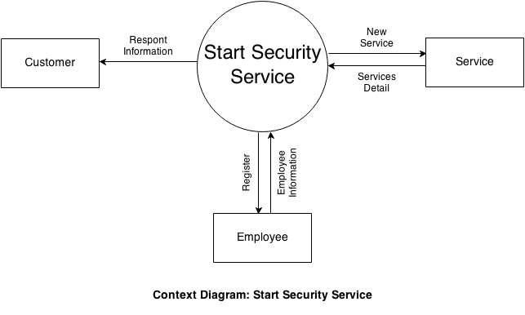**

**⏹ Level 0**

**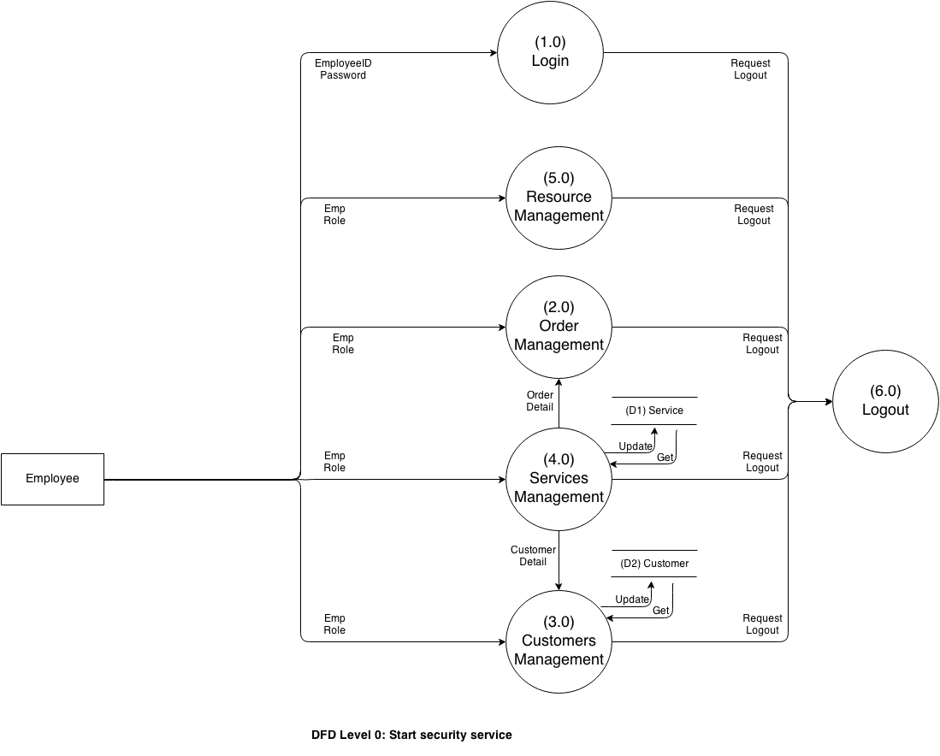**

**⏹ Level 1 – Login**

**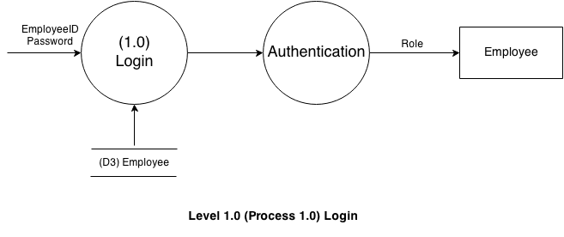**

**⏹ Level 1 – Logout**

**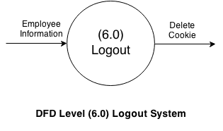**

**⏹ Level 2 – Order Management**

**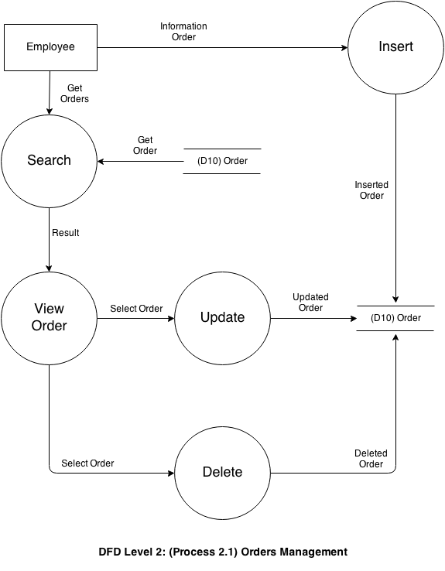**

**⏹ Level 2 – Customer Management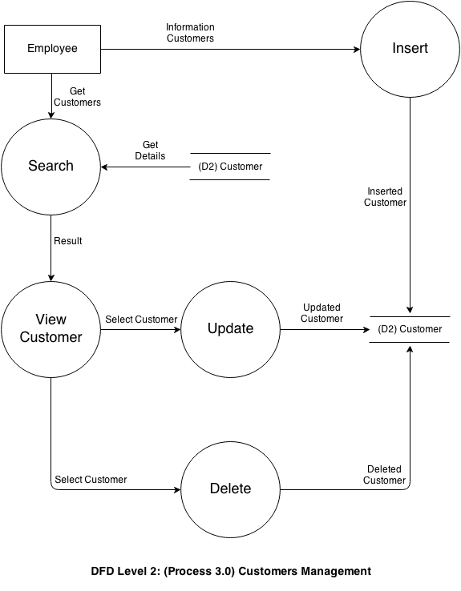**

**⏹ Level 2 – Account Management**

**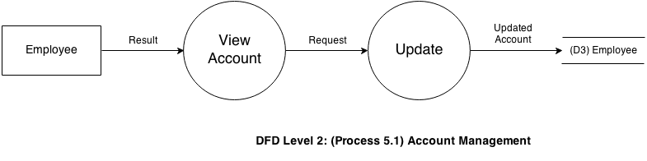**

**⏹ Level 2 – Employee Management**

**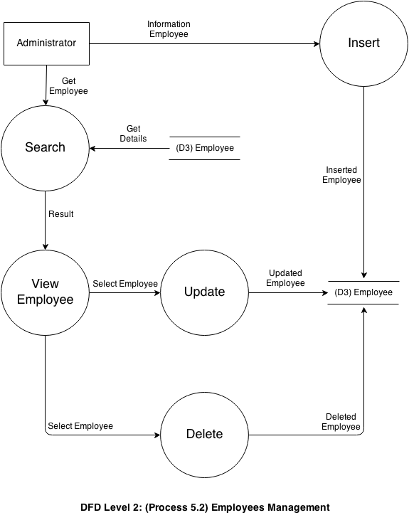**

**⏹ Level 2 – City management**

**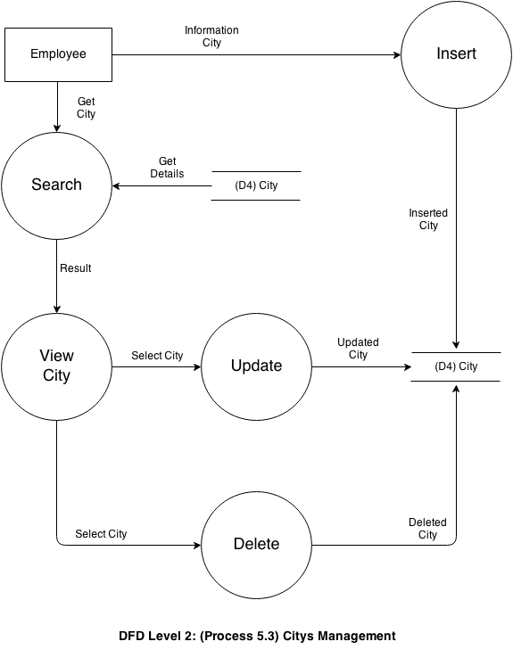⏹ Level 2 - Vacancy management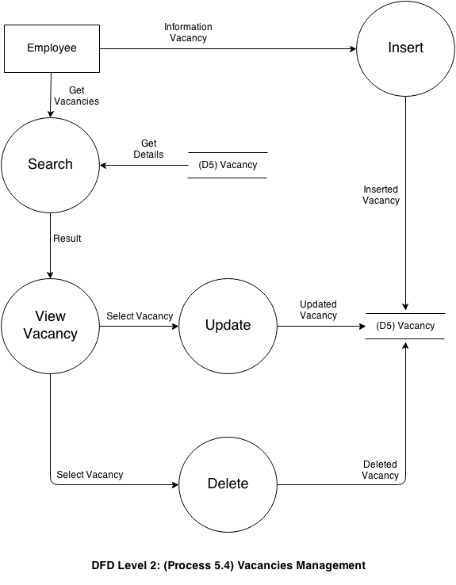**

**⏹ Level 2 – EduQual Management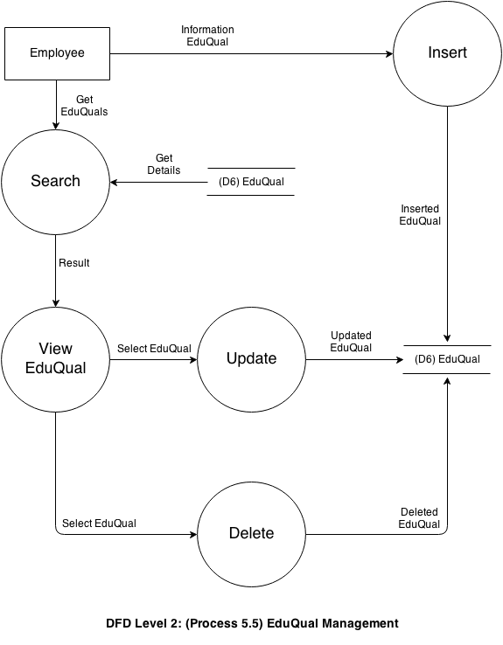**

**⏹ Level 2 – Title Management**

**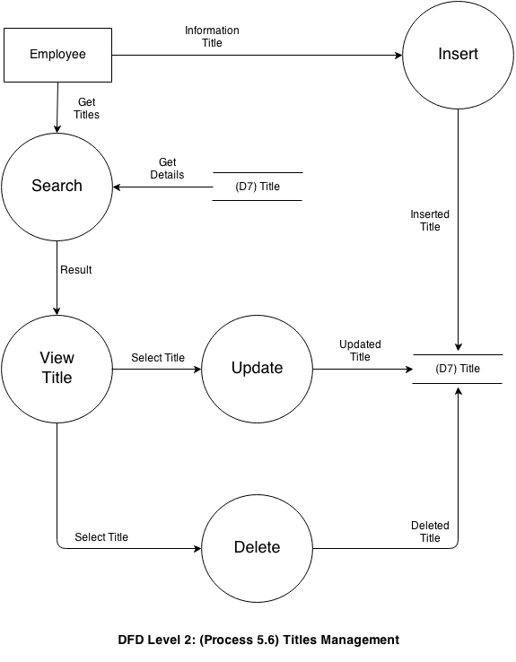**

**⏹ Level 2 - About Management**

**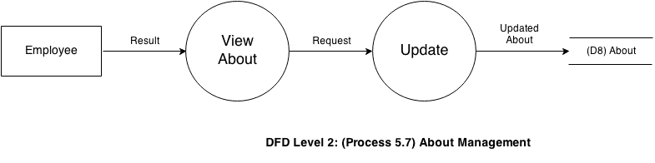**

**⏹ Level 2 – Region Management**

**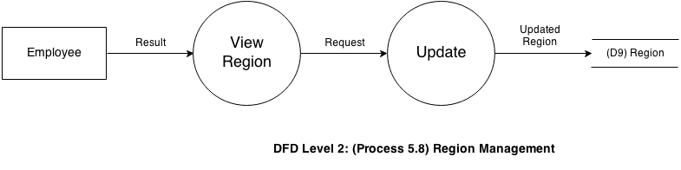**

VI. Entity Relationship (ER) Diagram ( Form No.6 )

**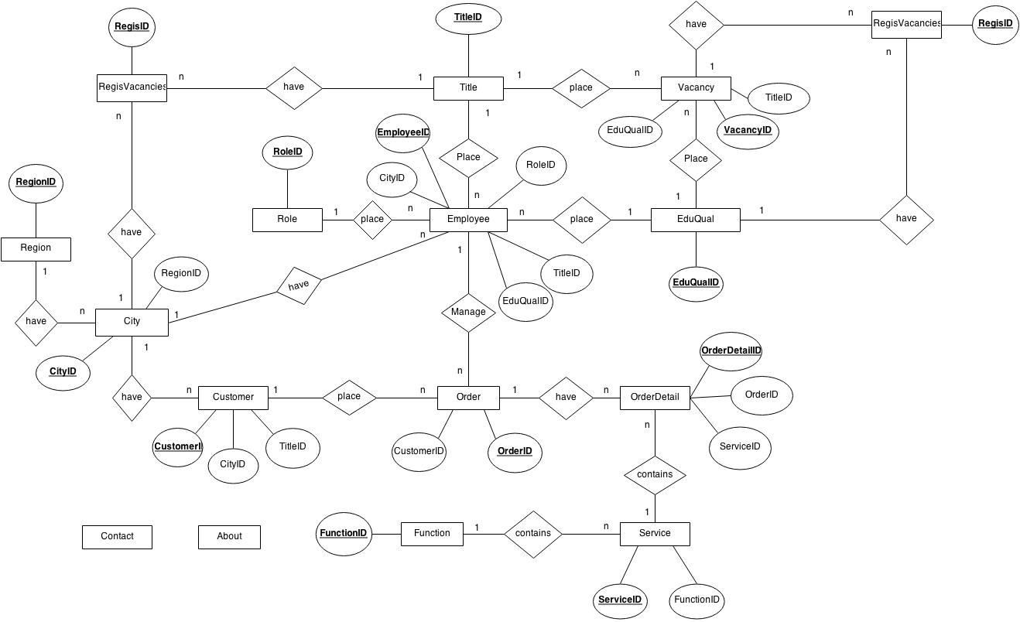**

**⏹ About Table**

**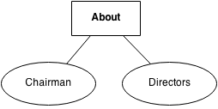**

**⏹ City Table**

**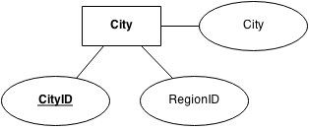**

**⏹ Contact Table**

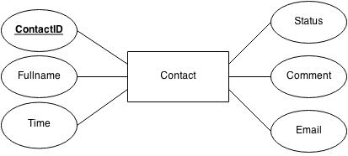

**⏹ Customer Table**

**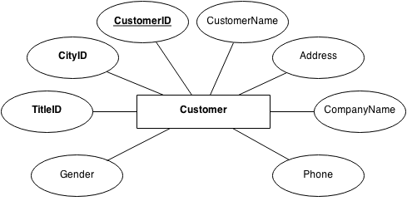**

**⏹ EduQual Table**

**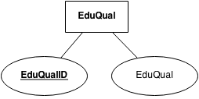**

**⏹ Employee** **Table**

**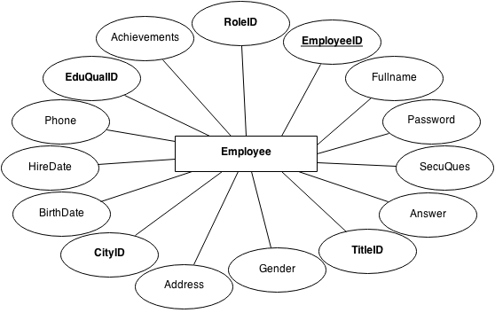**

**⏹ Function Table**

**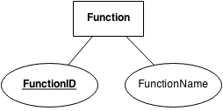**

**⏹ Order Table**

**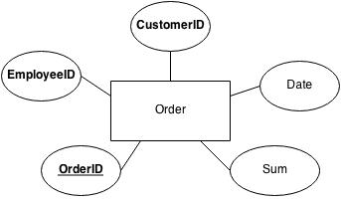**

**⏹ OrderDetail Table**

**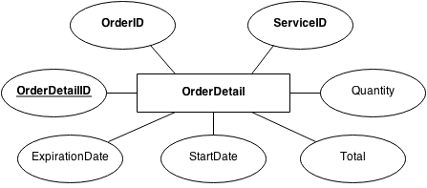**

**⏹ Region Table**

**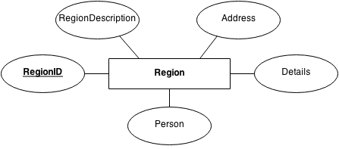**

**⏹RegisVacancy Table**

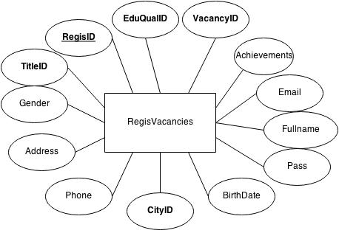

**⏹ Role** **Table**

**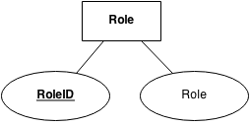**

**⏹ Service** **Table**

**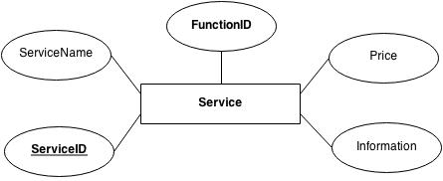**

**⏹ Title Table**

**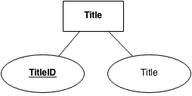**

**⏹ Vacancies**  **Table**

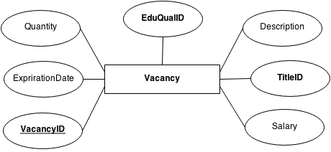

VII. Database Design/Structure ( Form No.7 )

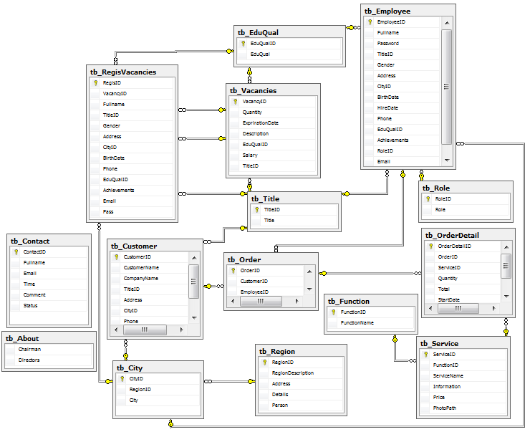

**⏹ About Table**

|  |  |  |  |
| --- | --- | --- | --- |
| **Field Name** | **Data Type** | **Constraints** | **Description** |
| Chairman | nvarchar(20) | Not null | Details about the chairman of company |
| Directors | nvarchar(80) | Not null | Details about the board members of company |

**⏹ City Table**

|  |  |  |  |
| --- | --- | --- | --- |
| **Field Name** | **Data Type** | **Constraints** | **Description** |
| CityID | int | Primary key | City’s identifier |
| RegionID | int | Foreign key references to Region Table | Region’s identifier number |
| City | nvarchar(50) | Not null | City’s name |

**⏹ Contact Table**

|  |  |  |  |
| --- | --- | --- | --- |
| **Field Name** | **Data Type** | **Constraints** | **Description** |
| ContactID | int | Primary key | Contact’s identifier |
| Fullname | nvarchar(30) | Allow null | Contact’s Name |
| Email | nvarchar(50) | Allow null | Contact’s email |
| Time | Datetime | Allow null | Contact’s datetime |
| Comment | nvarchar(max) | Allow null | Contact’s comment |
| Status | Bit | Allow null | Contact’s status |

**⏹ Customer Table**

|  |  |  |  |
| --- | --- | --- | --- |
| **Field Name** | **Data Type** | **Constraints** | **Description** |
| CustomerID | nvarchar(5) | Primary key | Customer’s identifier |
| CustomerName | nvarchar(30) | Allow null | Customer’s name |
| CompanyName | nvarchar(40) | Not null | Customer’s company |
| TitleID | int | Foreign key references to Title Table | Title’s identity number |
| Address | nvarchar(60) | Not null | Customer’s address |
| CityID | int | Foreign key references to City Table | City’s identifier number |
| Phone | nvarchar(24) | Allow null | Customer’s phone number |
| Gender | bit | Allow null | Customer’s email |

**⏹ EduQual Table**

|  |  |  |  |
| --- | --- | --- | --- |
| **Field Name** | **Data Type** | **Constraints** | **Description** |
| EduQualID | int | Primary key | EduQual’s identifier |
| EduQual | nvarchar(20) | Not null | EduQual’s name |

**⏹ Employee** **Table**

|  |  |  |  |
| --- | --- | --- | --- |
| **Field Name** | **Data Type** | **Constraints** | **Description** |
| EmployeeID | nvarchar(15) | Primary key | Employee’s identifier |
| Fullname | nvarchar(30) | Allow null | Employee’s name |
| Password | nvarchar(200) | Not null | Employee’s password |
| TitleID | int | Foreign key references to Title Table | Title’s identifier |
| Gender | bit | Allow null | Employee’s gender |
| Address | nvarchar(60) | Allow null | Employee’s address |
| CityID | int | Foreign key references to City Table | City’s identifier |
| BirthDate | datetime | Allow null | Employee’s birth date |
| HireDate | datetime | Not null | Employee’s hire date |
| Phone | nvarchar(15) | Allow null | Employee’s phone number |
| EduQualID | int | Foreign key references to EduQual Table | EduQual’s identifier |
| Achievements | nvarchar(50) | Not null | Employee’s achievements |
| RoleID | int | Foreign key references to Role Table | Role’s identifier |
| Email | nvarchar(50) | Allow Null | Email Employee |

**⏹ Function Table**

|  |  |  |  |
| --- | --- | --- | --- |
| **Field Name** | **Data Type** | **Constraints** | **Description** |
| FunctionID | int | Primary key | Function’s identifier |
| FunctionName | nvarchar(30) | Not null | Function’s name |

**⏹ Order Table**

|  |  |  |  |
| --- | --- | --- | --- |
| **Field Name** | **Data Type** | **Constraints** | **Description** |
| OrderID | int | Primary key | Order’s identifier |
| CustomerID | nvarchar(5) | Foreign key references to Customer Table | Customer’s identifier |
| EmployeeID | int | Foreign key references to Employee Table | Employee’s identifier |
| Sum | money | Allow null | Sum money |
| Date | Datetime | Allow null | Date contract |

**⏹ OrderDetail Table**

|  |  |  |  |
| --- | --- | --- | --- |
| **Field Name** | **Data Type** | **Constraints** | **Description** |
| OrderDetailID | int | Primary key | OrderDetail’s identifier |
| OrderID | int | Foreign key references to City Table | Order’s identifier |
| ServiceID | int | Foreign key references to City Table | Service’s identifier |
| Quantity | smallint | Not null | Quantity of order service |
| Total | money | Not null | Total money |
| StartDate | datetime | Not null | Start Date of order |
| ExpirationDate | datetime | Not null | Expiration Date of order |

**⏹ Region Table**

|  |  |  |  |
| --- | --- | --- | --- |
| **Field Name** | **Data Type** | **Constraints** | **Description** |
| RegionID | int | Primary key | Region’s identifier |
| RegionDescription | nvarchar(20) | Not null | Region’s description |
| Address | nvarchar(50) | Not null | Region’s address |
| Details | nvarchar(50) | Not null | Region’s details |
| Person | nvarchar(50) | Not null | Region’s contact person |

**⏹ RegisVacancies Table**

|  |  |  |  |
| --- | --- | --- | --- |
| **Field Name** | **Data Type** | **Constraints** | **Description** |
| RegisID | int | Primary key | RegisVacancies’s identifier |
| VacancyID | int | Foreign key references to Vacancy Table | Vacancy’s identifier |
| Fullname | nvarchar(30) | Allow null | RegisVacancies’s name |
| TitleID | int | Foreign key references to Title Table | Title’s identifier |
| Gender | bit | Allow null | RegisVacancies’s gender |
| Address | nvarchar(60) | Allow null | RegisVacancies’s address |
| CityID | int | Foreign key references to City Table | City’s identifier |
| BirthDate | datetime | Allow null | RegisVacancies’s birth date |
| Phone | nvarchar(15) | Allow null | RegisVacancies’s phone number |
| EduQualID | int | Foreign key references to EduQual Table | EduQual’s identifier |
| Achievements | nvarchar(50) | Not null | RegisVacancies’s achievements |
| Email | nvarchar(50) | Allow Null | Email Employee |
| Pass | Bit | Allow Null | Check pass interview |

**⏹ Role** **Table**

|  |  |  |  |
| --- | --- | --- | --- |
| **Field Name** | **Data Type** | **Constraints** | **Description** |
| RoleID | int | Primary key | Role’s identifier |
| Role | nvarchar(20) | Not null | Role’s name |

**⏹ Service** **Table**

|  |  |  |  |
| --- | --- | --- | --- |
| **Field Name** | **Data Type** | **Constraints** | **Description** |
| ServiceID | int | Primary key | Service’s identifier |
| FunctionID | int | Foreign key references to FunctionTable | Function’s identifier |
| ServiceName | nvarchar(30) | Not null | Service’s name |
| Information | nvarchar(100) | Not null | Service’s information |
| Price | money | Not null | Service’s price |
| PhotoPath | varchar(255) | Allow null | Photo of Service |

**⏹ Title Table**

|  |  |  |  |
| --- | --- | --- | --- |
| **Field Name** | **Data Type** | **Constraints** | **Description** |
| TitleID | int | Primary key | Title’s identifier |
| Title | nvarchar(30) | Not null | Title’s name |

**⏹ Vacancies**  **Table**

|  |  |  |  |
| --- | --- | --- | --- |
| **Field Name** | **Data Type** | **Constraints** | **Description** |
| VacancyID | int | Primary key | Vacancy’s identifier |
| Quantity | smallint | Not null | Vacancy’s quantity |
| ExprirationDate | datetime | Not null | Vacancy’s expriration date |
| Description | nvarchar(50) | Not null | Vacancy’s description |
| EduQualID | int | Foreign key references to EduQual Table | EduQual’s identifier |
| Salary | money | Not null | Vacancy’s salary |
| TitleID | int | Foreign key references to Title Table | Title’s identifier |

VIII. Task Sheet ( Form No.8 )

|  |  |  |  |  |  |  |  |
| --- | --- | --- | --- | --- | --- | --- | --- |
| **Project Ref. No.:** | | **Project title:**  ***Star security services*** | **Activity Plan Prepared by :** | **Date of Preparation of Activity Plan :** 26/03/2014 | | | |
| **Sr.**  **No.** | **Task** | **Actual Start Date** | **Actual Days** | **Team Member/ Names** | **Status** |
| 1 | Problem Definition (Form 1) |  |  | 29/03/2014 | 1 | ANH TRAN TUAN | 90% |
| 2 | Customer Requirement Specification (Form 2) |  |  | 29/03/2014 | 2 | ANH TRAN TUAN  KHOA PHAN VIET  DU NGUYEN HOANG | 80% |
| 3 | Entity Relationship (ER) Diagram (Form 6) |  |  | 29/03/2014 | 2 | ANH TRAN TUAN  KHOA PHAN VIET | 80% |
| 4 | Architecture & Design of the Project (Form No. 3): |  |  | 31/03/2014 | 1 | ANH TRAN TUAN | 100% |
| 5 | Database Design/Structure ( Form No.7 ) |  |  | 02/04/2014 | 1 | ANH TRAN TUAN | 80% |
| 6 | Data Flow Diagram (Form No.5) |  |  | 05/04/2014 | 3 | ANH TRAN TUAN | 80% |
| 7 | Flow Chart (Form No.4) |  |  | 05/04/2014 | 3 | ANH TRAN TUAN  DU NGUYEN HOANG | 80% |
| 8 | Database |  |  | 08/04/2013 | 1 | ANH TRAN TUAN | 90% |
| 9 | Master Page |  |  | 08/04/2013 | 5 | KHOA PHAN VIET | 90% |
| 10 | Login, Logout |  |  | 08/04/2013 | 15 | KHOA PHAN VIET | 70% |
| 11 | User management |  |  | 08/04/2013 | 15 | KHOA PHAN VIET | 70% |
| 12 | Add/ Delete Order |  |  | 12/04/2013 | 12 | ANH TRAN TUAN | 90% |
| 13 | Add/Update/ Delete Order Detail |  |  | 12/04/2013 | 12 | ANH TRAN TUAN | 90% |
| 14 | Edit Region/ About |  |  | 08/04/2013 | 3 | ANH TRAN TUAN | 90% |
| 15 | Add/ Update/ Delete/ Search Employee |  |  | 08/04/2013 | 4 | ANH TRAN TUAN | 80% |
| 16 | Add/ Update/ Delete/ Search Customer |  |  | 08/04/2013 | 4 | ANH TRAN TUAN | 80% |
| 17 | Add/ Update/ Delete/ Search Service |  |  | 12/04/2013 | 3 | ANH TRAN TUAN | 80% |
| 18 | Add/ Update/ Delete/ Vacancy |  |  | 12/04/2013 | 12 | ANH TRAN TUAN | 90% |
| 19 | Contact |  |  | 15/04/2013 | 8 | ANH TRAN TUAN | 90% |
| 20 | Reply contact |  |  | 15/04/2013 | 8 | ANH TRAN TUAN | 90% |
| 21 | Regis Vacancy |  |  | 15/04/2013 | 8 | ANH TRAN TUAN | 90% |
| 22 | Send mail to interview |  |  | 15/04/2013 | 8 | ANH TRAN TUAN | 90% |
| 23 | Forget password |  |  | 08/04/2013 | 13 | DU NGUYEN HOANG | 80% |
| 24 | Change password, edit account |  |  | 08/04/2013 | 13 | DU NGUYEN HOANG | 70% |
| 25 | Add/ Update/ Delete/ Search City |  |  | 12/04/2013 | 3 | DU NGUYEN HOANG | 85% |
| 26 | Add/ Update/ Delete/ Search Title |  |  | 12/04/2013 | 10 | DU NGUYEN HOANG | 80% |
| 27 | Add/ Update/ Delete/ Search Education Qualification |  |  | 12/04/2013 | 3 | DU NGUYEN HOANG | 85% |